中国药科大学-百济神州暑期课程联合培养教学大纲
Curriculum of BeiGene-University Joint Training Program
Overview of Drug Development: The Path from Bench to Bedside
药物开发之路： 从实验室到药房
Course introduction:
- Provide an understanding of interrelated activities throughout the drug discovery and development cycle for R&D, operations and/or commercialization.
- Design as an introduction course for college undergraduate or graduate students who are interested in Drug Development.
为对药物开发有兴趣的本科生及研究生而设计的入门课程
- Experienced instructors with diverse background and 100+ years of experience in pharmaceutical industry and regulatory agencies combined; also invites guest lecturer from Boehringer-Ingelheim (BI), who authored three books in drug development.
本课程由在制药行业和监管部门有着丰富经验的专家讲授，并特邀在BI工作并有三本药物开发专著的一位行业专家作客本课程。
- Timeframe: July-Aug. three sections per week, online.
7月至8月，每周3次在线课程

Each week is a 1.5 hour lecture
每周1个半小时课时
Num | Topics | Instructor | Date/Time (Beijing Time)
1 | Introduction and Overview of Drug Development  药物研发概述 | Geoff Kim | July 13 / 8:00-9:30 pm
2 | Pre-clinical Model  临床前模型 | Todd Palmby | July 14 / 8:00–9:30 pm
3 | Dose-finding and Clinical Pharmacology/Phase I 临床一期实验：定剂量和临床药理 | Chao Liu | July 15 / 8:00-9:30 pm
4 | Proof-of-Concept Trial/Phase II  临床二期实验：概念验证 | Naitee Ting, Guest Lecture | July 20 / 8:00-9:30 pm
5 | Pivotal/Confirmatory Trial/Phase III  临床三期实验：确认实验 | Jingjing Ye | July 21 / 8:00-9:30 pm
6 | Clinical Development in Clinical Trials  药物开发中的临床医学 | Huiyan (Vivian) Li | July 22 / 11:00-12:30pm
7 | Clinical Operation in Clinical Trials  药物开发中的临床运营 | Rajuli Lall | July 27 / 11:00-12:30pm
8 | Data Management in Clinical Trials  药物研发中的数据管理 | Zhenkai Zhao | July 28 / 11:00-12:30 pm
9 | Statistical Programming in Clinical Trials  药物研发中的统计编程 | You (Leo) Li | July 29 / 11:00 – 12:30 pm
10 | Clinical Statistics: Study Design and Analysis  药物开发中的统计：实验设计跟分析 | Xiao Lin | Aug. 3 / 11:00 – 12:30 pm
11 | Biomarker in Drug Discovery and Development 药物研发中的生物标记 | Yun Zhang, Yiling Yu | Aug. 4 / 11:00 – 12:30 pm
12 | Regulatory Agencies’ Role in Drug Development and Regulatory Innovations  国际监管部门的角色跟监管创新 | Yutao Gong | Aug. 5 / 8:00-9:30 pm
13 | Pharmacovigilance  药物警戒 | Yijing Zhang | Aug. 10 / 11:00 – 12:30 pm
14 | Manufacturing  药物生产 | Richard Lu, Yuchuan Gong, Lei Ling | Aug. 11 / 11:00 – 12:30 pm
15 | Payer and Patient Access  医保系统 | Boxiong Tang | Aug. 12 / 8:00-9:30 pm
16 | Pharmaceutical Portfolio and Program Management  制药行业里的项目组合管理 | Ling Xue | Aug. 17 / 11:00 – 12:30 pm
17 | Product Life-cycle and Marketing  药品上市和生命周期管理 | Shanmei Liao | Aug. 18 / 11:00 – 12:30 pm
18 | Real-World Evidence  真实世界证据 | Bobby Reddy | Aug. 19 / 8:00-9:30 pm

Instructors:
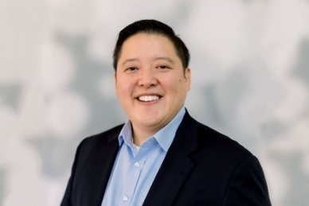 Geoffrey Kim, MD
Geoffrey Kim, MD joined BeiGene as the VP, Applied Innovation. In this role, Geoff and his team innovates and incubates technological solutions to ultimately increase patient access to clinical trials and novel therapeutics. The team also creates novel methodologies to capture, house, integrate, and analyze data from disparate sources to drive strategies to advance pipeline development and streamline the advancement of effective therapies and combinations.
Dr. Kim joined BeiGene from AstraZeneca where he was most recently the VP, Oncology Regulatory Science and Strategy, leading the regulatory function and initiating regulatory strategies in the rapidly changing landscape of oncology drug development. Geoff joined AstraZeneca in 2017 as the VP, Strategic Combinations, where he established the development and commercial strategies for immuno-oncology-based combinations, external collaborations, and women’s cancers.
Prior to joining AstraZeneca, Geoff was director of the Division of Oncology Products 1 in the Office of Hematology Oncology Products at the U.S. Food and Drug Administration, where he oversaw the evaluation and regulation of oncology drug products for breast, genitourinary and gynecologic cancers. He was also involved with numerous cross-functional working groups, developing policies pertaining to in-vitro companion diagnostics, combination products, and therapy dose optimization strategies for cancer medicines.
Dr. Kim completed his medical oncology fellowship at the National Cancer Institute (NCI) where he was active in both laboratory and clinical research in molecular signaling and ovarian cancer. He received his medical degree from New York Medical College and completed his residency in internal medicine at the Montefiore Medical Center.

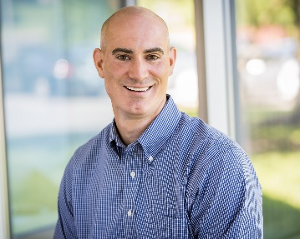 Todd Palmby, PhD
Todd Palmby has been working in oncology drug development across various roles in industry and government for 13 years. Since joining BeiGene in 2020, he has been Senior Director for US Regulatory Science and Strategy within the North America and Latin America Regulatory Affairs group helping to drive consistent regulatory recommendations to support informed decision making for early pipeline and business development opportunities. In 2018, Todd began his industry career as Director of Early Portfolio Strategy at AstraZeneca providing strategy support from the Oncology Business Unit to early development project teams. Todd spent nearly 10 years as a Pharmacology and Toxicology reviewer and team lead supporting clinical divisions in the Office of Hematology and Oncology Products within the Center for Drug Evaluation and Research at the US FDA. During this time, he contributed to the review of numerous submissions across hematology and solid tumor indications from pre-IND through life cycle management, including 17 new molecular entity approvals, had an active role in development of FDA and ICH guidance documents and provided leadership through various internal and external activities. He received a PhD in Pharmacology from the University of North Carolina at Chapel Hill followed by post-doctoral training at the National Institutes of Health.

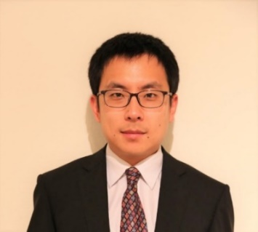 Chao Liu, PhD
刘超博士2014年获得佛罗里达大学免疫学博士和统计学硕士。同年加入FDA，从事临床药理相关的研究工作。2015年到2017年在临床药理办公室担任定量药理评审员，主要疾病领域涉及肿瘤，血液病和风湿病。2017年到2019年担任定量药理评审组组长，带领评审团队参与上百项IND和数十项NDA/BLA的评审。疾病领域主要集中在血液病，心脑血管和感染性疾病。2019年加入百济神州，在应用创新团队中担任量化分析总监, 主要负责竞争情报集合系统的开发。同时对肿瘤药物和相关可转化的新兴技术进行市场评估，收入预测和估值，并为应用创新团队提供有关临床和商业风险/价值的分析框架。
Dr. Chao Liu received his Ph.D. in Immunology and a Master of Statistics from the University of Florida in 2014. He joined the FDA in the same year and engaged in the research on clinical pharmacology. From 2015 to 2017, he served as a pharmacometrics reviewer in the Office of Clinical Pharmacology, reviewing drug applications in oncology, hematology, and rheumatology. From 2017 to 2019, he served as the pharmacometrics team leader, leading the team to participate in the review of hundreds of INDs and dozens of NDA/BLA, with disease areas mainly focused on hematology, cardiovascular diseases, and infectious diseases. Dr. Liu joined BeiGene in 2019 and served as the director of quantitative solutions in the Applied Innovation team, mainly responsible for the development of the informatics hub of competitive intelligence, performing market assessments, revenue forecasts, and real-time valuation to guide innovative technology development and implementation by applied innovation, and providing analytic frameworks to evaluate the risk/return profile.

Naitee Ting（丁迺迪）, PhD, 美国统计学会 院士
Naitee Ting is a Fellow of American Statistical Association (ASA). He is currently a Director in the Department of Biostatistics and Data Sciences at Boehringer-Ingelheim Pharmaceuticals Inc. (BI). He joined BI in September of 2009, and before joining BI, he was at Pfizer Inc. for 22 years (1987-2009). Naitee received his Ph.D. in 1987 from Colorado State University (major in Statistics). He has an M.S. degree from Mississippi State University (1979, Statistics) and a B.S. degree from College of Chinese Culture (1976, Forestry) at Taipei, Taiwan.
Naitee published articles in Technometrics, Statistics in Medicine, Drug Information Journal, Journal of Statistical Planning and Inference, Journal of Biopharmaceutical Statistics, Biometrical Journal, Statistics and Probability Letters, and Journal of Statistical Computation and Simulation. His book “Dose Finding in Drug Development” was published in 2006 by Springer, and is considered as the leading reference in the field of dose response clinical trials. The book “Fundamental Concepts for New Clinical Trialists”, co-authored with Scott Evans, was published by CRC in 2015. Another book “Phase II Clinical Development of New Drugs”, co-authored with Chen, Ho, and Cappelleri was published in 2017 (Springer). Naitee is an adjunct professor of Columbia University and University of Connecticut. Naitee has been an active member of both the ASA and the International Chinese Statistical Association (ICSA).

Jingjing Ye, PhD
叶京晶博士2007年获加州大学戴维斯分校的统计博士。同年加入辉瑞公司从事临床前和转化医学的统计研究工作,主要在癌症领域。2010加入FDA，从事医疗器诫跟癌症新药审批的统计工作。在FDA新药中心，2018-2020年担任癌症新药评审的统计组组长，带领评审团队参与上百项IND和三十多项NDA/BLA的评审。也作为统计组长参与了FDA癌症卓越中心（OCE）监管创新多个项目的审批，包括癌症卓越中心的环球审批项目。叶博士也是FDA新药中心跟癌症卓越中心儿童用药委员会统计代表。在2020年1月加入百济，担任数据科学跟卓越运营的全球负责人，主要负责百济数据创新和卓越运营的部门，职责涵盖从临床前，临床实验到生产。项目包括支持竞争情报系统，临床试验中的可视化数据收集和清理，中心监察，流程制定和优化还有自动化的工具开发。

Dr. Jingjing Ye received her PhD in statistics from University of California, Davis. She joined Pfizer Global Research and Development in 2007 as a statistics manager in non-preclinical/pre-clinical and translational science, mainly worked in oncology therapeutic area. She joined FDA in 2010 and was a primary statistician reviewing medical device and new oncology drugs for approval. She was promoted to statistical team leader in 2018. In FDA Center for Drug Evaluation and Research (CDER), she served as the statistics team leader, leading the team to participate in the review of hundreds of INDs and 30+ NDA/BLA in oncology and hematology drugs. Dr. Ye served as statistical lead in several regulatory innovations in oncology center of excellence (OCE), including Project Orbis. She also served as statistical representative in CDER and OCE Pediatric Review Committee (PeRC), overseeing all operations related to pediatric drug development. Dr. Ye joined BeiGene in Jan. 2020. She is global head of Data Science and Operational Excellence (DSOE) in Global Statistics and Data Sciences (GSDS). Her team promotes innovation and operational excellence, works cross-functionally to support various organizations within BeiGene from pre-clinical, clinical to manufacturing, including competitive intelligence, visualization tools and interactive trial data monitoring and cleaning, central monitoring in clinical trials, process development and efficiency improvement and automation of various tools to support program deliverables.

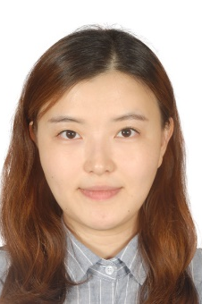 Huiyan (VIVIAN) LI, MD 李慧燕
Dr. Vivian Li is currently Associate Medical Director in Clinical Development I/O, BeiGene. She is responsible for clinical development of ZW25 (anti-HER2 bispecific antibody)/ZW49 (anti-HER2 Antibody-Drug-Conjugates). She was trained as a Gynecologist medical doctor, specialized in GYN oncology, in Peking University People’s Hospital. Prior to BeiGene, she has industry experience in multiple pharmaceutical companies including Bristol-Myers Squibb and Sanofi, with focus in oncology area. Her responsibilities cover compounds with different mechanism of actions (MOAs), e.g. chemotherapy, immunotherapy, targeted therapy, etc. She has worked for multiple functions: clinical development, medical affairs and portfolio strategy.

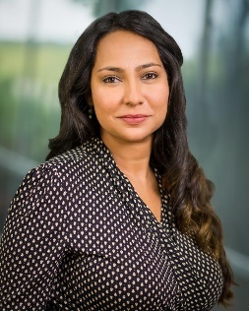 Rajuli Lall
Rajuli Lall has about 15 years of drug development experience with expertise in Oncology and Immuno-Oncology. Rajuli is currently working on a technology and associated processes to optimize the way clinical research is conducted. Prior to her role at Beigene within the Applied Innovation team, Rajuli was the Global ClinOps leader at AstraZeneca in the Women’s Cancers and Novel Combinations team. Rajuli has managed a large portfolio of clinical trials from ground up and has led several database locks, inspections, BLA/MAA submissions over the course of her career in Pharma and Biotech. Rajuli was a Bench Scientist prior to taking on a Clinical Development role at a Biotech company.

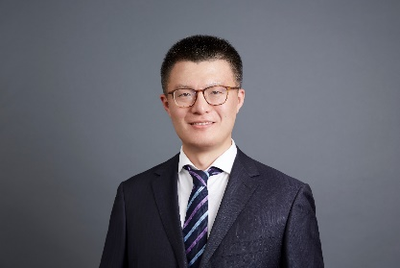 Zhenkai Zhao 赵振凯
赵振凯拥有约11年的工作经验包括默沙东，科文斯（美国实验室控股有限公司），ICON等。现为百济神州数据管理部门武汉数据运营负责人。赵振凯于2016年4月份加入百济神州，当时是中国数据部门的第一位人员。赵振凯参与了泽布替尼澳洲一期临床试验至中国关键二期临床试验，直至泽布替尼获得中国和美国的获批上市。赵振凯现在武汉带领一个超过40人的数据团队。
Zhenkai Zhao has about 11 years experience, from MSD, Covance (Lab Corp), ICON, etc, now served as Wuhan DM group lead in BeiGene. Zhenkai joined Beigene in April 2016, who is the first data manager in China. Zhenkai invovled the Brukinsa’s clinical development from phase I in Australia, to the pivotal studies submited to China and US agency. Zhenkai now based in Wuhan, lead a DM team with more than 40 members.
Leo Li, 李友
李友，百济神州高级总监，统计编程中国负责人。 李友拥有20年的临床试验经验，具有熟练的编程技巧和出色的领导能力。 在加入百济神州之前，李友曾在凯维斯、赛诺菲和信达等任职。 在过去的这些年中，李友出色完成了多个重磅新药的临床研究数据统计分析工作，成功获得中国、美国、欧洲和日本等国家药监部门批准上市。李友本科毕业于北京大学医学部药学专业，并在中国疾控中心获得环境卫生医学硕士学位。

Leo Li, Sr. Director, the statistical programming China head in BeiGene. Leo has 20-year experience in clinical trial, strong statistical programming skills and great leadership. Before joined BeiGene, Leo has worked for KendleWits, Sanofi and Innovent. In the past years, Leo has successfully completed the statistical analyses of the clinical trials for several new blockbuster drugs, which have been submitted and approved by NMPA, FDA, EMA and PMDA. Leo graduated from Peking University with a bachelor’s degree in Pharmaceutics and received a master’s degree in Environmental Health from the China CDC.

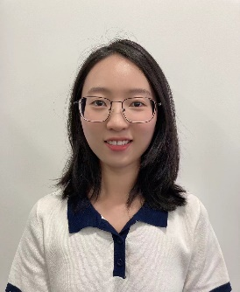 Lin Xiao, PhD, 林晓
林晓拥有中国药科大学生物统计博士学位，2018年博士毕业后加入百济神州生物统计部门，现任首席生物统计师。自加入百济以来，曾参与/支持多项II，III期临床试验以及中美注册申报，为多项临床研发方案提供统计学支持。除项目之外，还参与/完成多项研究课题，包括基于贝叶斯方法的决策模型在早期临床试验的应用，篮式设计最优生物标记物界值选择，治疗转换方法在抗肿瘤药物研发中的应用等。重点研究领域涉及：生存分析，贝叶斯方法，适应性设计等。

Lin Xiao received her PhD degree in statistics from China Pharmaceutical University. After her graduation in 2018, she joined BeiGene GSDS and currently is Principal statistician. She supported several Phase II, III clinical trials and filings, provided statistical supports to clinical development plan. Besides project-level experiences, she joined/completed several research topics, including Bayesian decision making in early phase trials, optimal biomarker cutoff in basket trial design, application of treatment switching in oncology, and so on. The interested research area covers survival analysis, Bayesian method, adaptive design.

Yun Zhang, PhD, 张韵
本科毕业于北京大学医学部，后赴美国费城德雷赛尔大学（Drexel University）医学院获药理学博士学位。
回国后加入上海恒瑞医药研发公司，任肿瘤免疫体内药效组长，带领团队完成多个包括大小分子的肿瘤免疫项目临床前疗效评估及候选分子筛选。
2016年加入百济，负责肿瘤免疫全球临床项目的生物标志物策略及伴随诊断开发。

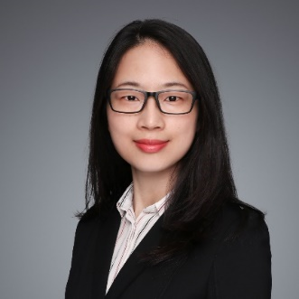 Yiling Yu, MD, PhD, 俞亦龄
俞亦龄拥有10+年新药研发经验。曾任职于诺华生物医学研究中心负责再生医药和表观遗传学药物研发，之后加入强生研发中心生物标记物部门负责组织病理平台研发，在肺癌、淋巴瘤、骨髓瘤、乙肝等不同疾病领域中，为新药早期研究到后期开发各阶段的项目，发现并验证了可用于临床研究的生物标志物。自2018年加入百济（上海）生物科技有限公司，现担任临床生物标志物总监，负责血液肿瘤领域的生物标志物临床研发策略的制定和执行、伴随诊断试剂的共同开发、转化医学研究等。拥有复旦大学医学学士及人体解剖与组织胚胎学博士学位，博士期间在美国St. Jude儿童研究医院主攻发育神经生物学研究。
Yiling Yu has over 10 years working experience in drug discovery and development in pharma industry. She previously worked for Novartis Institute for Biomedical Research, where she worked on the biology of regeneration therapy and epigenetic drug discovery. Then she joined Janssen Pharmaceutical Companies of Johnson & Johnson and led the histopathology group in biomarker department, to identify and validate biomarkers in disease area of lung cancer, lymphoma, myeloma, HBV, for projects ranging from the early discovery to the late clinical development stages. Yiling joined BeiGene in 2018, currently as Director of Clinical Biomarker. She is now leading the design and execution of the biomarker strategy for BeiGene’s clinical drug development for hematological malignancy. She also oversees co-development of BeiGene’s companion diagnostic as well as translational research in heme disease area. Yiling holds MD and PhD degree in Anatomy, Histology and Embryology.

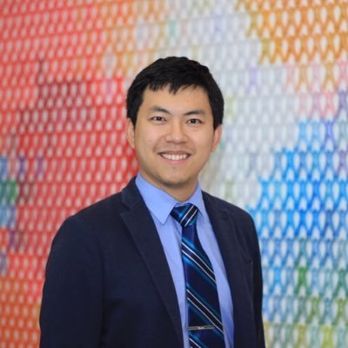 Yutao Gong, PhD
Yutao Gong, PhD started working as the director of regulatory analytics at BeiGene since August 2020. He leads the team to provide analytical solutions to regulatory needs with multiple topics. Before joining BeiGene, he was the lead data scientist of FDA oncology. He performed the safety analytics on 70+ NDA/BLA oncology applications submitted to both CDER and CBER. And he had 30+ publications in medical oncology and regulatory science while he worked at FDA.

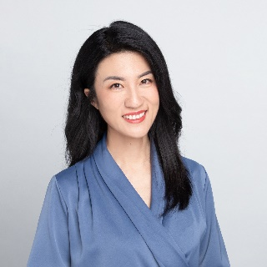 Yijing Zhang
张轶菁，从事药物警戒工作十余年， 曾就职于默沙东和拜耳药物警戒团队，曾任拜耳中国药物警戒负责人，加入百济之前创建昭衍鸣讯提供药物警戒咨询和业务服务。现任百济神州药物警戒高级总监.

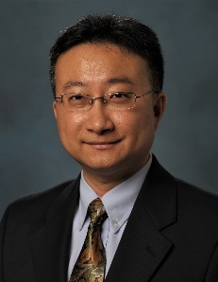 Yuchuan Gong, Ph.D., 龚豫川

龚豫川博士在东南大学取得化学工程本科学位，在波多黎各大学取得物理化学博士学位，以及芝加哥大学取得MBA学位。
龚豫川博士在制药行业有17年的从业经验。曾在明尼苏达大学药学院担任教授。 之后先后加入Vertex Pharmaceutical （富泰制药），Abbott Laboratories/AbbVie（雅培、艾伯维），Celgene/BMS（新基，施贵宝）等跨国制药公司任职。在此过程中，龚豫川博士积累了丰富的从药物分子到上市产品的全面研发，生产，以及申报的经验。龚博士参与及主导了多个小分子药物的研发。 其中包括12个上市产品（包括Venclexta, Oriahnn FDC, Fedratinib,和Zeposia等）。龚博士拥有多于10项专利，多于20篇论文及章节。
在Celgene/BMS（新基，施贵宝）担任产品研发总监期间，龚博士不仅提高了公司内部产品研发的能力，更有效地联合了原料药，分析，产品研发部门，以及生产部门，极大地提高了整体产品研发的效率。龚博士于2021年3月加入百济，担任CMC负责人。龚博士将致力于和其他相关部门一起，进一步提高百济药物研发的效率和质量。

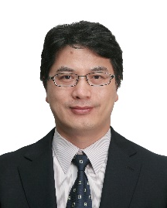 Liqiang (Richard) Lu陆利强
陆利强是 百济神州（苏州）生物科技有限公司的苏州生产运营负责人。陆利强有超过30年医疗领域工作经验。 加入百济前曾任葛兰素史克苏州&葛兰素史克南京（2017）董事总经理&工厂总监 （2012/01-2019/10），默沙东上海总经理&工厂总监（2009/10 - 2012/01）和默沙东上海，强生杭州，罗地亚无锡的质量负责人。

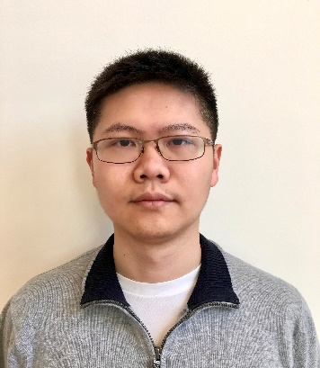 Lei Ling, PhD, 凌磊
凌磊，清华大学化学工程与工业生物工程学士，普渡大学（Purdue University）化工博士，现任广州百济生产科学技术（MST）总监，负责临床后期以及国内外商业化产品的技术转移和商业化生产的技术支持。 加入百济之前先后任职于美国BMS生物药原液（DS）和制剂（DP）MS&T部门，从事实验研究，生产支持，技术转移和生命周期管理等工作。

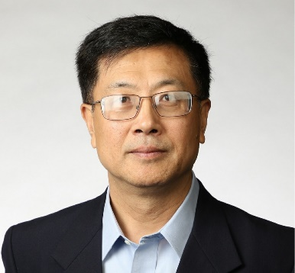 Boxiong Tang, MD, PhD

唐伯雄博士现任百济神州（BeiGene)卫生经济学和结果研究（HEOR）执行总监。他建立了百济国际卫生经济学和结果研究团队，负责HEOR职能并实施全球卫生经济学及成果研究战略。
在加入百济神州之前，他曾担任梯瓦（Teva）制药全球卫生经济学和成果研究以及增长市场的高级总监。 唐博士在任上创立了梯瓦成长市场部市场准入及卫生经济学和结果研究团队.
唐博士曾任辉瑞制药公司新兴市场亚洲健康结果研究高级总监。负责制定和实施临床开发（专门从事卫生经济学评估和病人报告的成果，产品价值档案），和上市后产品（大型数据库的建立和分析）的研究策略。唐博士的专业研究包括肿瘤学，血液学和免疫学（生物制剂）的治疗领域。在辉瑞任职之前，唐博士曾在强生公司和葛兰素史克公司担任卫生经济学和临床疗效研究总监，负责卫生结果研究，生物制剂和肿瘤学研究。
唐博士同时兼任复旦大学客座教授,及浙江大学医学院客座研究员等。唐博士曾任国际药物经济学健康成果研究协会（ISPOR）亚洲分会工业委员会会长。他在医药，卫生经济学和结果研究学有超20年的经验。
唐博士拥有预防医学，卫生服务研究的博士学位，以及公共卫生学硕士学位主攻卫生规划和国际健康。
他发表了30多篇的学术论文,文章，100多篇科学文稿，文摘以及在各类重大国际科学大会上的演讲。他主攻世界各国的卫生技术评估（HTA）及HTA在世界各地的发展。此外，他曾在国际卫生经济学会（iHEA）科学委员会，医疗决策学会（SMDM），以及美国管理服务杂志单任评审。

Dr. Tang has over 23 years experiences in medicine, public health, and health economics and outcomes research.

Currently, he is the Executive Director, Head of Health Economics and Outcomes Research (HEOR) at Beigene ex-China Medical Affairs, responsible for developing HEOR function and implementing health outcomes research strategies globally. He established HEOR function to support the product launches and reimbursement globally.

Before joining Beigene, he served as a Sr. Director of Global HEOR, and Growth Markets at Teva Pharmaceutical. Dr. Tang has established the newly created Growth Markets Market Access and HEOR team within Teva.

Previous, Dr. Tang was a Senior Director of Health Outcomes Research at Pfizer Emerging Markets supporting Asia region. His responsibilities includes developing and implementing research strategies in clinical development (specialized in health economics assessment and patient reported outcomes, product value dossiers), and post market products (real world and large database creation and analysis). Dr. Tang is specialized in therapeutic areas of oncology, hematology, and immunology (biologics), and women’s health.

Prior to Pfizer, Dr. Tang was the director of Health Economics and Clinical Outcomes Research in Johnson & Johnson and GlaxoSmithKline, where he was responsible for health outcomes research in biologics and oncology.

He was also an adjuvant professor of China Fudan University and faculty of Zhejiang University Medical School. Meanwhile, Dr. Tang was the Chair of the HTA (Industry) Committee, Asia Consortium of the International Society of Pharmacoeconomics and Outcomes Research (ISPOR), and a member of Asia Consortium Executive Committee.

Dr. Tang’s training includes a MD in Preventive Medicine, a PhD in Health Services Research, and a MPH in Health Planning and International Health.

Dr. Tang serves as the chair of Industry Committee of International Society of Pharmacoeconomics and Outcomes Research (ISPOR) Asia Consortium. He has published more than 30 manuscripts in peer review journals, 100+ abstracts and numerous speeches and presentations in major scientific congresses including ISPOR. He is knowledgeable in the development of Health Technology Assessment around the world. In addition, he served at Scientific Committees of International Health Economics Association (iHEA), Society for Medical Decision Making (SMDM), and a Peer Reviewer of America Journal of Managed Care.

Ling Xue, Ph.D., 薛玲 博士

百济神州项目综合管理亚太负责人

- 具有15年以上新药开发和研究的经验，涵盖临床前，转化医学以及临床研究多个领域。
- 加州大学伯克利分校获得博士学位，曾就职于加州大学癌症研究中心，BioGenex, Pharmacyclics, 参与第一代BTK抑制剂依鲁替尼的研发和上市。
- 2015年加入百济，直接参与泽布替尼和雷利珠单抗的研发和上市，目前从事临床项目的综合管理
- 2016年入选中国青年千人计划, 2017年入选北京海聚人才计划, 2018年入选中关村高端领军人才。

Head of Portfolio and Program Management, APAC

- Have more than 15 years of experience on drug discovery and development, including pre-clinical, translational and clinical studies.
- Obtained doctor degree of University of California at Berkeley; worked at Cancer Research Laboratory at UC-Berkeley, BioGenex, Pharmacyclics; and involved in the drug development and approval of first-generation BTK inhibitor (imbruvica).
- Joined Beigene in 2015, contributed to the development and commercialization of Zanubrutinib and Tislelizumab, and focusing on portfolio and program management now.
- Selected for China Young Thousand Plan 2016, Beijing oversea high-level talent program 2017, and Zhongguancun leading talent 2018.

Shanmei Liao, PhD
廖珊妹拥有约14年药厂生物统计经验。任职于BMS美国和辉瑞中国，现为百济神州上市后统计负责人。曾参与/领导多项新药/生物类似物研发及6项中/美注册申报，负责过几十项一期至四期临床研究。疾病领域涉及实体瘤，血液肿瘤，免疫，神经，病毒，心血管，生物类似物研发等。自2019年担任百济神州上市后统计负责人后，带领团队支持了多项国内外真实世界研究设计，确证性试验监管机构讨论，医保谈判疗效经济模型分析及监管交流，真实世界数据库及PRO分析报告支持上市产品证据链，及上市后安全数据监测。拥有北京大学概率统计本科和美国加州大学戴维斯分校统计博士学位。
Shanmei Liao has about 14 years working experience in pharma/biotech industry. She worked for BMS US and Pfizer China and currently is the post approval stat group lead in Beigene. She has worked/led about 6 China and US filings, and covered dozens of phase 1 to phase 4 clinical trials, in therapeutic areas as I/O, heme, I/I, neuro science, virology, CV/MED and biosimilar development. After taking the role of post approval stat lead in Beigene, she has led multiple China and exChina RWD studies design, PMC regulatory discussion, NRDL package analyses and regulatory discussion, RWD and PRO analyses for post approval evidence generation, and quantitative monitoring for post marketing PV data. She got her PHD from University of California at Davis and a Bachelor degree from Peking University, both in statistics.

Bobby Y. Reddy, MD
Bobby Y. Reddy, MD is a physician scientist who currently leads strategy for the Applied Innovation group at BeiGene. He joined BeiGene from AstraZeneca, where he was Head of Oncology Regulatory Science and Innovation and a member of the Global Oncology Regulatory Science and Strategy leadership team, which oversaw and provided strategic regulatory guidance for AstraZeneca’s oncology pipeline. Prior to industry, he was a faculty member at Harvard Medical School and an attending physician at Massachusetts General Hospital (MGH) and MGH’s Melanoma and Pigmented Lesion Center.. At HMS, he investigated the role of genetic and immunologic factors in melanoma development and progression, along with novel therapeutic strategies. He is a board-certified dermatologist and continues to teach and practice at MGH.

